www.twisterflasher.com
sales@twisterflasher.com

Test point solution for Ericsson for Twister Users

T610, T616, T618, T628, T630

Connect the red crocodile to the battery connector on the pcb like shown in the picture below.

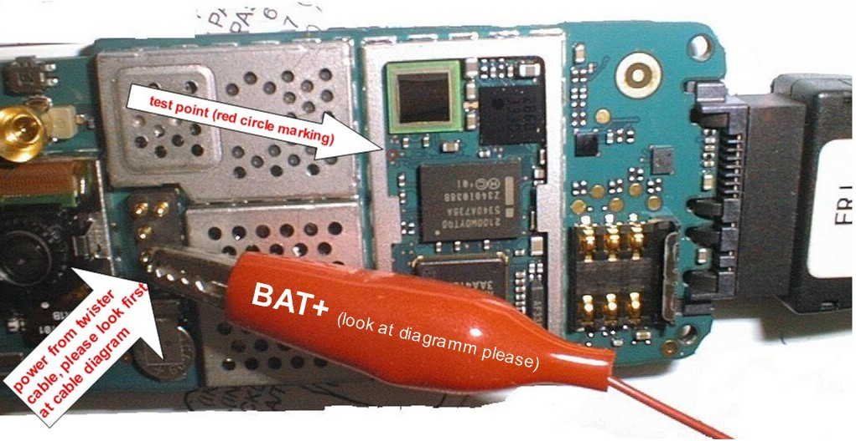

Test point is marked with the arrow as shown in the picture below

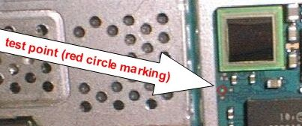

Z600, Z608 PCB

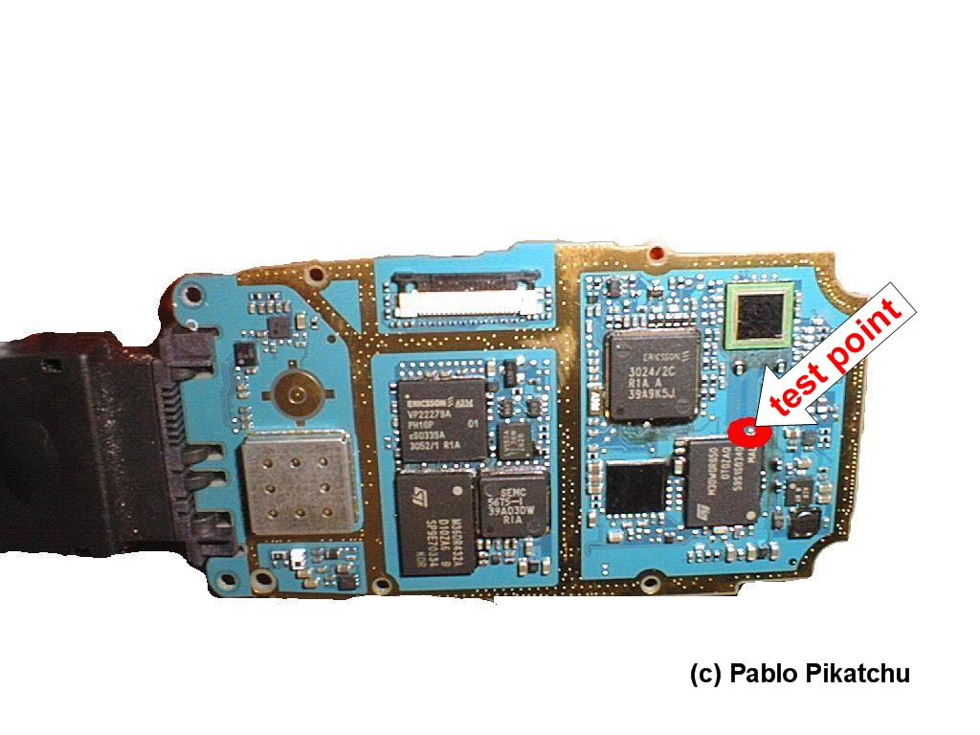

“z600 TEST POINT”
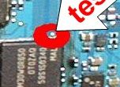

“z600 POWER SUPPLY” (have a look at the picture below)

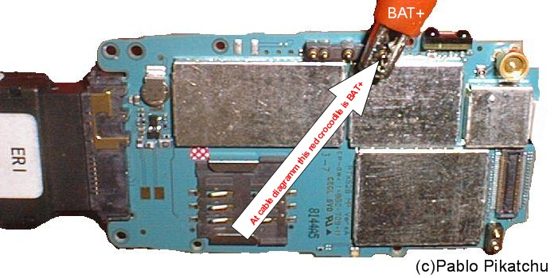

HOW TO USE

- Connect cables and power supply “Crocodile”
(Must have modified cable: UFSx_Ericsson_RD_Cable.pdf)
- Press “GO” button in RTP_UFS software.
- Connect TEST POINT to GND (Ground)
- When boot is bypassed, disconnect TP fast.
- Now you can do what you want:
Flash, downgrade, unlock.

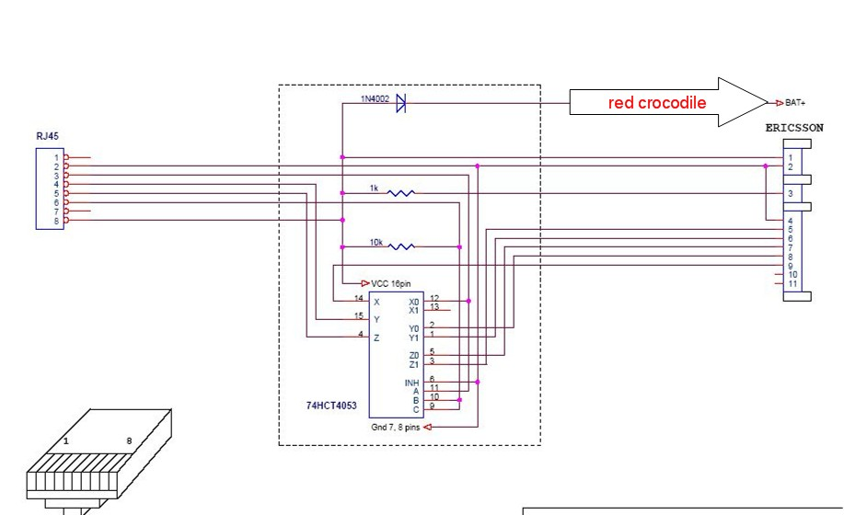

NOTE: This solution use on YOUR RISK ONLY. It is tested and works.

Credits goes to to Twister Team.

© Pablo Pikatchu

