GLOBAL GSM SERVICE SUPPORT

FIELD SERVICE BULLETIN

Title: T2288 Intermittent No Camp Issue

Date: 26th February 2002

Number of Pages: 2

Bulletin Ref. No: CD 0072

Product: T2288

System: GSM Dual Band

Problem:

A quantity of T2288 units have been shipped with the incorrect L203 part fitted. These units were manufactured in the Easter Inch facility in 2001. The exact number of units built with this issue is not known due to the closure of the facility with the subsequent lose of traceability.

There are 3 possible symptoms, which will be reported by the customer when the wrong inductor is placed on the board: “Lose Camp”, “Intermittent Camp” or “Drops Calls After Several Minutes”.

Solution:

This issue has been linked, solely, to the Easter Inch facility. No other facilities have been linked to this issue.

Service Action:

When a T2288 phone is received with the customer complaint of “Lose Camp”, “Intermittent Camp” or “Drops Calls After Several Minutes”, the L203 inductor should be checked to ensure correct component is placed.

Figure 1 shows where to look on the PCB to identify if the correct part is used.

Figure 2 has the correct inductor placed, which is a blue wire wound part.

Figure 3 has the incorrect part placed, which is a chip inductor that can be identified by its brown colour and resemblance to a capacitor part.

Figure 4 depicts how to measure the Charge Pump voltage to confirm if the rework has been successful. To enable Charge Pump voltage, connect PCB to Test Set and allow to camp. Then take voltage level as depicted in Figure 4.

If it is confirmed that the wrong part is placed on the board, the component should be replaced with the following part number: 2462587P23.

If the correct part is placed the normal debug procedure should be followed.

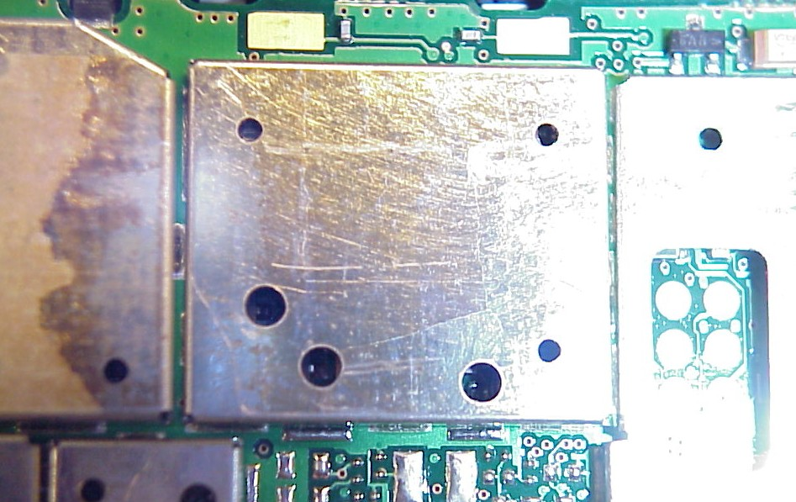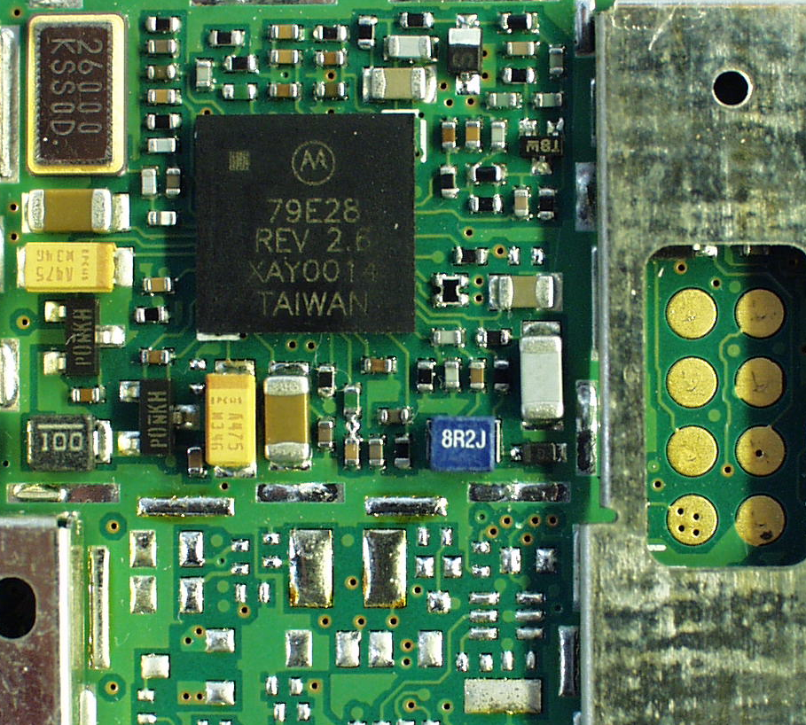
Look through right side of shield hole to verify which L203 is placed.
Correct part placed
Figure 1
Figure 2

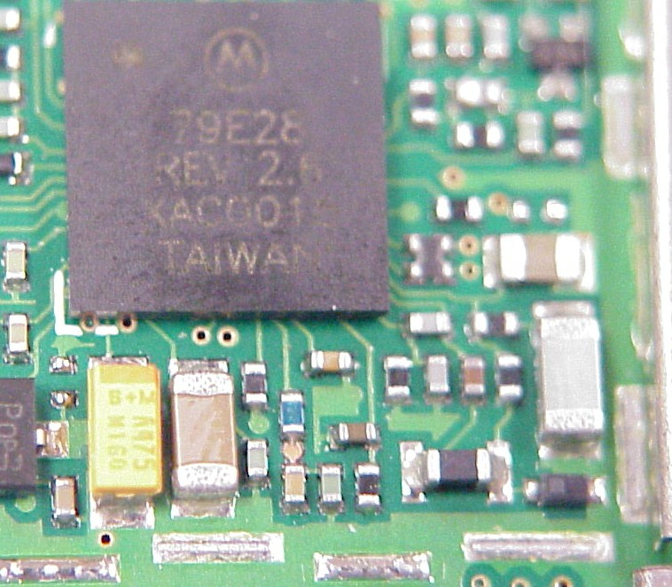
Incorrect part placed
Measure CP Voltage here (R205).
4 – 4.5Vdc with incorrect part placed.
2 – 2.4Vdc with correct part placed.
Figure 3
Figure 4

